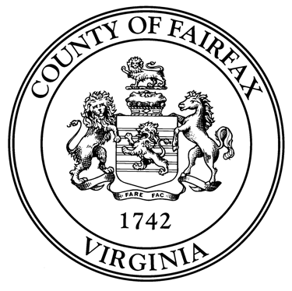
County of Fairfax, Virginia

To protect and enrich the quality of life for the people, neighborhoods and diverse communities of Fairfax County

FAIRFAX COUNTY BOARD OF SUPERVISORS

ECONOMIC INITIATIVES COMMITTEE MEETING

June 13, 2023
9:30 AM – 11:00 AM
J. Hamilton Lambert Conference Center (Room 11)

AGENDA

- Opening Remarks and Approval of Meeting Summary from March 14th, 2023 EIC meeting (10 minutes)

- Tysons Community Alliance (40 minutes)
The TCA will provide a progress report on the establishment of the new organization and recent activities, an overview of its upcoming strategic planning process, and introduce its new Chief Executive Officer.
- Josh White, Board Chair, Tysons Community Alliance
- Rich Bradley, Interim Chief Executive Officer
- Katie Cristol, Chief Executive Officer

- Talent Up – Work-Based Learning Opportunity Fund Proposal (40 minutes)
  - Michael Becketts, Director, Department of Family Services
  - Rebecca Moudry, Director, Department of Economic Initiatives
  - Theresa Benincasa, Manager, Economic Mobility, Department of Economic Initiatives
  - Daniel Mekibib, Assistant Division Director for Workforce Development, Public Assistance and Employment Services Division, Department of Family Services
  - Bill Browning, Manager, Workforce Innovations, Public Assistance and Employment Services Division, Department of Family Services

