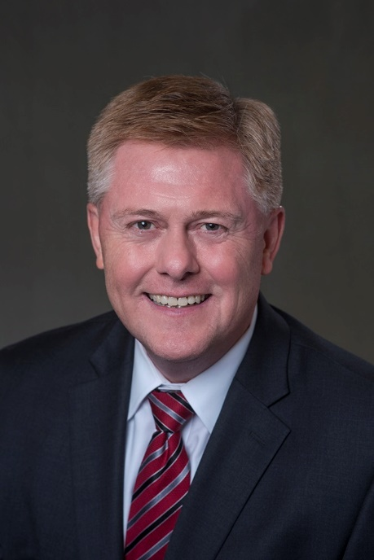
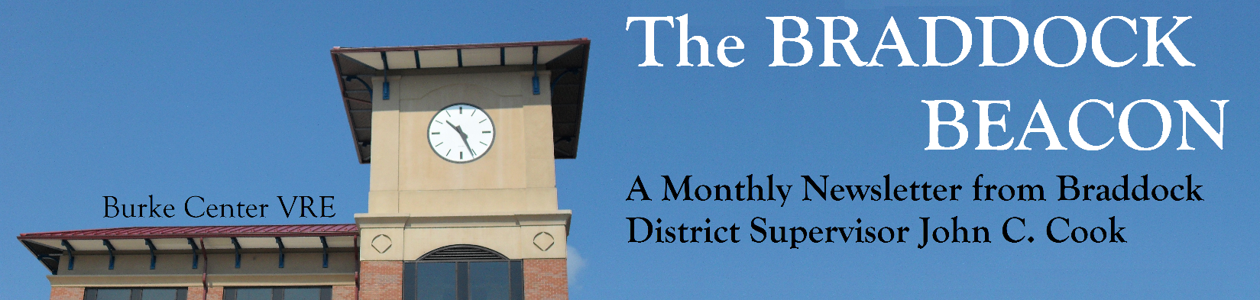
The new year promises to be full of important issues and opportunities for engaged citizens to work together to make the Braddock District, and Fairfax County, a better place to live. Here are some expected highlights of the year to come:
Supervisor Cook’s Preview of 2017

January 12, 2016
Volume 9 │ Issue 1
Supervisor Cook has served on the Fairfax County Board of Supervisors since 2009 and lives in Kings Park with his wife and SIX children.
Braddock District Issues
- Braddock Road Multimodal Study
We expect to conclude the Braddock Road Multimodal Study by mid-2017. While the study has taken longer than expected, citizen participation has been instrumental in exploring all possible options in the study. The study showed the difficulty presented by options that would add lanes to the road, given the increasing north-south traffic and rush hour traffic on Braddock Road in both directions morning and afternoon. Results from the traffic studies will be presented at the February 6 community meeting (detailed on page 3 of the Beacon), along with proposed pedestrian improvements. Further transit recommendations will come later in the Spring.
Supervisor Cook has served on the Fairfax County Board of Supervisors since 2009 and lives in Kings Park with his wife and six children.

- Former Northern Virginia Training Center Property
The Commonwealth is expected to finalize a contract with its preferred buyer very soon, and after a due diligence period, the prospective buyer may announce its proposed redevelopment plans in the spring. It is likely that any proposed redevelopment would require both a comprehensive plan amendment and rezoning. While the Commonwealth has imposed limits on community and county input into rezoning applications, the same is not true of comprehensive plan changes. Therefore, if the buyer requests a comprehensive plan change, I will launch a community planning process to review whatever is proposed and to make recommendations from the community perspective.

- Lake Accotink Master Plan and Audrey Moore RecCenter Renovations
The Park Authority is expected to conclude its planning process for the future of Lake Accotink Park in the coming year. This “Master Plan Review” includes significant opportunities for community input. What are your ideas for the future of this county-owned jewel? Step up and be part of planning its future. In addition, we will continue to look at the renovation needs of the Audrey Moore RecCenter. This aging facility needs a major facelift. You can be part of the process to bring this important asset into the 21st century.
County-Wide Issues
- Budget
The County budget will be especially challenging this year. Why? Because the economy is not growing fast enough to meet the community’s expectations. I look at the budget this way: beginning with a baseline of maintaining the current level of programming, the County needs approximately a three percent increase in revenue each year to “stay even.” This is because inflation is around a percentage and a half, and population growth runs a little short of one percent a year. Some county expenses, such as health insurance and some vendor contracts, see larger cost increases. The County employee compensation plan costs around three percent a year. Added together, about a three percent revenue increase keeps program levels constant. If you want more services, then revenues need to increase even more. If you want to pay less, then services need to be reduced. This year, real estate assessments are barely increasing, and with current tax rates, revenue will probably rise less than two percent. Therefore, cuts will be needed just to keep other programs at baseline.
There are also new programs, such as mental health initiatives, police oversight and reform, and sexual assault prevention, among others, that should be funded. Schools will ask for more funding again, and it is not likely that their requests will be met in full, requiring more reductions. Given the four penny increase in the property tax rate that occurred just last year, and voters’ rejection of the meals tax, I think it is unlikely the Board will increase the property tax rate further. Therefore, cutbacks will be the theme of this year’s budget. The County Executive releases his proposed budget on February 14, 2017, which will kick off our formal budget deliberations.

- Public Safety Oversight
As Chair of the Board’s Public Safety Committee, I will continue to lead county efforts to implement policies to reduce police use of force, improve police training, and provide treatment instead of incarceration for those with mental illness who end up in “the system” for minor offenses. This will bring together in the strongest way possible our community and our police. Citizen review and independent oversight will increase community confidence in the police. This will result in a stronger police department with even greater support in the community. I will also lead efforts to improve our already excellent Fire and Rescue Department. In addition, I hope to improve our emergency response system with more community involvement and more attention to the needs of seniors and people with disabilities.
Community Engagement
As always, our success as a county depends on the engagement of our residents. I will continue to provide support to our civic and homeowner associations, community pools, and other community organizations. I urge you to increase your personal involvement in our community. Don’t say “when is someone going to do something about …” Instead, look in the mirror and say, “what can I do to make my community a better place to live?”. I will again offer community-building programs for our district and look forward to your involvement. We live in interesting times, and the challenges and opportunities before us are even more complex. Don’t leave the future of our community to others. Jump in and be part of the answer!

Supervisor Cook Asks Residents to Complete Community Issues Survey
Supervisor Cook would like residents of the Braddock District to fill out a brief ten question survey on the issues facing Fairfax County and the Braddock District. The survey can be found online, and the responses will help Supervisor Cook determine the opinions of his constituents. The results of the survey will be posted in next month’s issue.
Braddock Road Community Meeting Set for February 6
Supervisor Cook will hold a Braddock Road Community Meeting on February 6 from 6:30 to 9 p.m. in the cafeteria of Lake Braddock Secondary School to update the community on the status of the Braddock Road Multimodal Study. At 6:30, attendees can ask questions of Fairfax County Department of Transportation (FCDOT) staff and review information at various stations. At 7:30, attendees will be presented with the recommendations from the Braddock Road Task Force, a citizen council formed by Supervisor Cook to provide input and review potential improvements to Braddock Road from Guinea Road to the Beltway.
BDC to Host Annual School Board Budget Meeting in February
The Braddock District Council of Community Associations (BDC) will be hosting its annual meeting with representatives from the School Board to go over the details of their FY2018 budget request. Attendees will hear from Ilyong Moon, at-large School Board member, and from Kristin Michael, FCPS Assistant Superintendent for Financial Services. The meeting will take place on February 8 at 7:30 p.m. in the Kings Park Library meeting room.

Questions? Comments? Ideas? Call Supervisor Cook’s office at 703-425-9300 or email us at Braddock@fairfaxcounty.gov
This Month in the Braddock Beacon…

Braddock Neighborhood News – Page 4
Cook in the Community – Page 4
Community Information – Page 5
Human Services Corner – Page 6
Environmental Update – Page 7
Land Use Update – Page 10

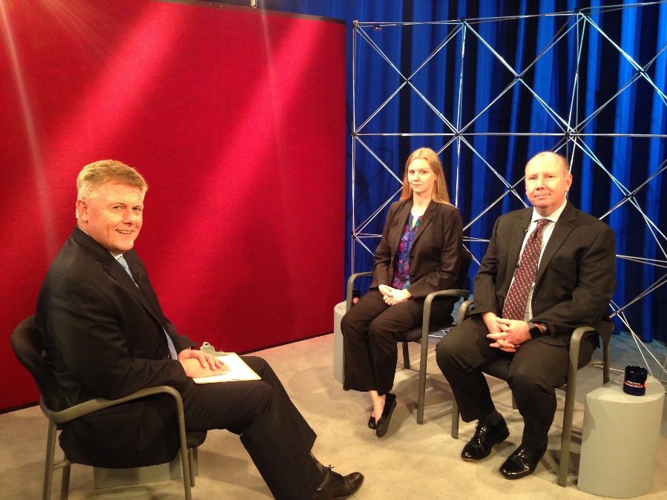
Supervisor Cook hosts a monthly television show, Braddock Neighborhood News, on Fairfax County Channel 16, which is available on most cable networks. Supervisor Cook invites topical guests to share pertinent and informative items with the viewers.
Braddock Neighborhood News
Our library system is the largest in the state, and one of the largest nationwide. Because of this, we have a number of resources available to us that other jurisdictions do not. To meet the ever-changing needs of county residents, our library branches are constantly working to update their services and materials.
This month, Supervisor Cook invited Library Director Jessica Hudson, along with Michael Donovan, the Braddock representative to the Library Board, to come on BNN and tell the viewers about their mission of working to give us the best Fairfax Library possible.
Cook in the Community
This month, Supervisor Cook sat down with Library Director Jessica Hudson and Michael Donovan, who sits on the Library Board.
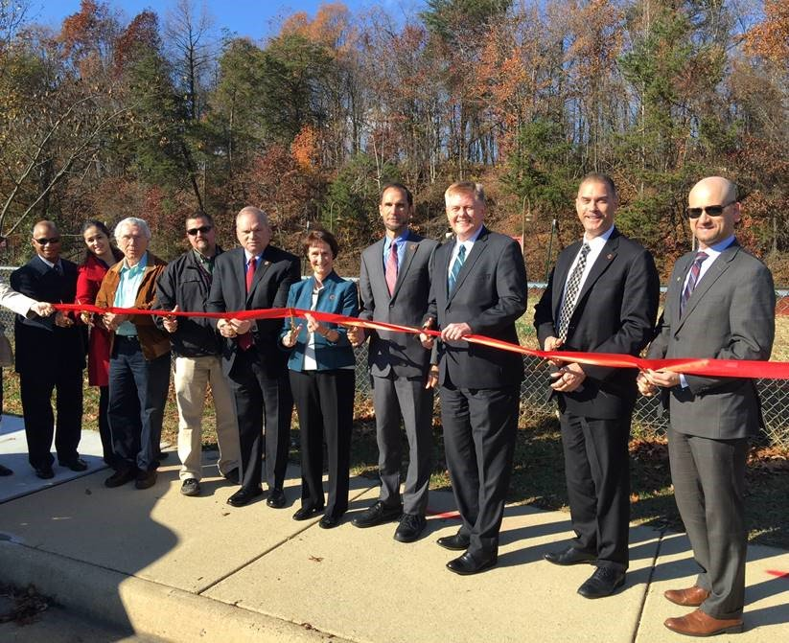
VRE Park and Ride Ceremony – On December 1, Supervisor Cook gave remarks at the ribbon cutting ceremony for the new Park and Ride facility in Lorton.
Duffy House Santa’s Workshop – On December 10, Supervisor Cook stopped by Burke United Methodist Church and talked to the many volunteers who were helping with the Duffy House Santa’s Secret Workshop.
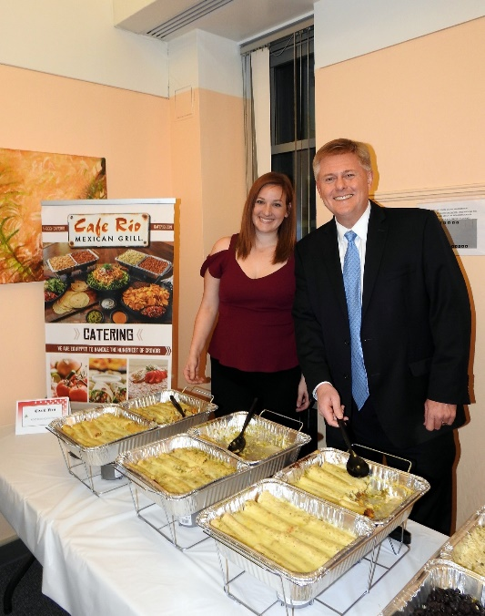
Santa Train – In keeping with tradition and the spirit of the season, on December 10, Supervisor Cook took his family on the magical VRE Santa Train excursion. This is one of the most popular winter events for some people and is part of VRE’s Operation Lifesaver program which helps to educate people about rail safety. People were also encouraged to bring a new unwrapped toy to be given to Toys for Tots.
Supervisor Cook cuts the ribbon on the Lorton VRE Station Park and Ride expansion project
Webelo Cub Scout Meeting – On December 11, Supervisor Cook went to Olam Tikvah Congregation in Fairfax to talk to a group of Cub Scouts who had many questions about his role as a local elected official and also what they can do to be better citizens.
FCPD Santa’s Ride – On December 13, Supervisor Cook and his colleagues took a short break from a day full of committee meetings at the Government Center to welcome Santa’s Little Helpers from the Fairfax County Police Department. The motorcycle officers assigned to this seasonal mission are tasked with collecting toys for sick children who are currently in area hospitals, like INOVA Fairfax and Children’s Hospital in Georgetown. They started their mission with a photo-op in front of the Government Center.
Many local businesses donated food to the community at this year’s Taste of Braddock
Taste of Braddock – On December 14, Supervisor Cook once again greeted hundreds of citizens at his annual Taste of Braddock Holiday Reception. The event is always well attended and delicious food from many local restaurants was available. Mark your calendar for our next Taste of Braddock on December 10, 2017.
West Springfield Police Holiday Reception – On December 16, Supervisor Cook took time to stop by the West Springfield Police Station to share a little holiday cheer with some of the officers who continually work to keep us safe.
Community Information
Code Compliance Corner
The topic of this month’s Code Compliance Corner is the issue of outdoor storage. With the leaves off of the trees, citizens may begin to notice construction materials, appliances, tires, equipment, boxes, furniture, items covered by a tarp or canvas cover, and other random outdoor storage items on their neighbor’s property that may not have been visible when leaves were on the trees. Article 10-102 of the Fairfax County Zoning Ordinance regulates the size and location of outdoor storage, and if it is excessive or located improperly on the lot, DCC can issue a Notice of Violation to have it removed. A flyer with more information can be found online.
History Celebrations and County Events
2017 will bring a full year of celebration in honor of Fairfax County’s 275th anniversary. Take a look at these events happening in the County:
January 15: “MLK Day Celebration: Chuck D,” McLean Community Center, 2 – 3 p.m., $20 Gen. Adm.
January 16: “Dr. Martin Luther King, Jr. March and Celebration,” march line up begins at 12:30 pm, celebration program begins at 2 p.m., meet at South Washington Street and South Maple Avenue in Falls Church, FREE
January 19: “Inauguration Day at Walney,” Ellanor C Lawrence Park, 7 – 8 p.m., $6 per person
January 28: “The CSS Shenandoah and the Last Shot of the Civil War,” Civil War Interpretive Center at Historic Blenheim, 2:00 p.m., FREE
Celebrate Fairfax Educational Workshops
Celebrate Fairfax, Inc. (CFI) will be offering two to four event planning educational workshops on a monthly basis. Upcoming classes focus on PR and Social Media (Jan. 25), and Creative Event Programming (Jan. 30). Register now for these free 2-hour courses at: http://celebratefairfax.com/cv-event-training-program/.
For more information, please contact Barry Feil at 703-324-5311 or by email at Barry.Feil@FairfaxCounty.gov. TTY 711. Reasonable accommodations available upon advance request.
Human Services Corner
CrisisText Available to Students and Parents
CrisisText is a text messaging tool for students and parents who need help with mental health, depression, or thoughts of suicide. It is a confidential, safe, and non-judgmental resource when you need someone to talk to. Trained crisis counselors who respond can also provide information about emergency resources in the community. CrisisText is available on the FCPS Mobile App or by sending the text “NEEDHELP” to 85511. CrisisText is provided as a community resource through a partnership with FCPS, Fairfax County Government, the Fairfax-Falls Church Community Services Board, and PRS Services. Youth may also call 703-527-4077 if they would prefer to speak with someone directly. Additional community resources are available through:

- Merrifield Community Services Board Emergency Center: 703-573-5679
- Merrifield Community Services Board Walk-In (without appointment): Monday-Friday 9-5 for screening and assessment for behavioral health care services
- Mobile Crisis Unit: 1-844-627-4747
- National Suicide Prevention Lifeline: 1-800-273-TALK (8255)

AARP Foundation Tax-Aide Program
The AARP Foundation Tax-Aide Program helps provide free tax preparation and electronic filing services to taxpayers of all ages. AARP counselors are trained to prepare Virginia, Maryland, DC, and federal returns. They handle most forms of income, and work to ensure that taxpayers receive applicable credits and deductions. This program is available February 1 through April 18. While the vast majority of community members served by the AARP are in the low and middle income ranges, there are no income limits. These 12 sites provide free tax preparation and electronic filing services:

Mason District Government Center
6507 Columbia Pike
Annandale, VA 22003
Tuesday, Wednesday, Friday 9:30 a.m. to 1 p.m.
Monday & Thursday 1 p.m. to 8 p.m.
Saturday 9 a.m. to 1 p.m.

Sherwood Regional Library
2501 Sherwood Hall Lane
Alexandria, VA 22306
Monday thru Saturday 10:15 a.m. to 2 p.m.
Monday thru Thursday 5 p.m. to 8 p.m.

SunTrust Bank of Vienna
515 Maple Avenue East
Vienna, VA 22180
Monday thru Friday 10 a.m. to 2 p.m.

Arlington Central Library
1015 North Quincy Street
Arlington, VA 22201
Tuesday 10 a.m. to 7 p.m. (Opens Jan 31)
Thursday 10 a.m. to 4 p.m.

Centreville Regional Library
14200 St. Germain Drive
Centreville, VA 20121
Tuesday 4 p.m. to 8 p.m.
Wednesday 1 p.m. to 5 p.m.

Columbia Pike Branch Library
816 South Walter Reed Drive
Arlington, VA 22204
Tuesday 1:15 p.m. to 7:45 p.m.
Friday & Saturday 10 a.m. to 2 p.m.

James Lee Community Center
2855 Annandale Road
Falls Church, VA 22042
Tuesday & Thursday 1 p.m. to 4:30 p.m.

Environmental Update
Bull Run Regional Library
8051 Ashton Avenue
Manassas, VA 20109
Monday 10 a.m. to 6 p.m.
Thursday 12 p.m. to 8 p.m.

Providence Community Center
3001 Vaden Drive
Fairfax, VA 22031
Saturday 10 a.m. to 2 p.m.

Mott Community Center
12111 Braddock Road
Fairfax, VA 22030
Thursday 9:30 a.m. to 1:30 p.m.
Saturday 1 p.m. to 5 p.m.

Reston Community Center
2310 Colts Neck Road
Reston, VA 20191
Tuesday 9 a.m. to 2 p.m.
Thursday 4:30 p.m. to 8:30 p.m.
Saturday 9 a.m. to 3 p.m.

Chinn Park Regional Library
13065 Chinn Park Drive
Woodbridge, VA 22192
Tuesday & Thursday 10:30 a.m. – 3 p.m.
Sunday, March 5 & March 19 12 p.m. - 3 p.m.

Virginia Trees for Clean Water Program
Through funds from the USFS Chesapeake Watershed Forestry Program and Virginia Department of Conservation and Recreation, the Virginia Department of Forestry has developed a Virginia Trees for Clean Water program which is designed to improve water quality by planting riparian buffers and trees in our neighborhoods and communities.
Potential projects funded under the program include tree planting activities of all types such as riparian buffer or community and neighborhood tree plantings. Winning proposals should demonstrate the merit of the project and long-term tree maintenance must be considered. Funding is available on a 50/50 match basis and in-kind match including volunteer time is permissible.
Grants are awarded through this program to encourage local government and citizen involvement in creating and supporting long-term and sustained canopy cover. All applications are due by 5:00 pm on Thursday February 16.
Native Seedling Sale
On February 1st, ordering will open for the Conservation District's native seedling sale. For sale will be a tree bundle (3 species, 6 seedlings for $11.95) and a small tree and shrub bundle (5 species, 10 seedlings for $16.95). This year's theme is "fall color." All species were chosen to give your yard a pop of bright fall foliage, and as always, all are native to Virginia and wildlife friendly!
The Conservation District's annual seedling sale makes low-cost bare-root native shrub and tree seedlings available to Northern Virginia residents. Seedling packages are announced in January, go on sale in February and are available for pickup in late April or early May. Trees and shrubs help cleanse water, prevent soil erosion, provide habitat, cool our climate and clean our air. Consider adding native trees and shrubs to your community!
Seeking Funding for Your Conservation and Efficiency Projects?
Want to do something environmentally friendly on your property? Is heavy runoff causing you distress? Do you have poor energy efficiency in your community's club house? The new Conservation Assistance Program (CAP) can help. It provides technical assistance and up to 50% matching funding for qualifying projects. For more information about CAP - including application deadlines, eligible projects and funding levels - please visit the program webpage at http://www.fairfaxcounty.gov/nvswcd/cap/.
Become a Virginia Master Naturalist!
The Master Naturalists are a core of volunteers that perform service to manage and protect natural areas through activities such as plant and animal surveys, stream monitoring, trail rehabilitation, and teaching in nature centers. Applications are now open for the basic training course that trains new volunteers to become Master Naturalists. Topics covered include ecology, geology and soils, native flora and fauna, habitat management, and more. Fairfax Chapter training will be held Thursdays 7-10 p.m. from February 23 to May 18 at the Fairfax County Government Center. Applications are due January 23rd. Arlington Chapter training will be on Mondays 9 a.m. – 3 p.m. from February 27 to May 22. Applications are due January 27th. You do not have to be a county resident to apply.
Plant NOVA Natives Campaign Looking for Steering Committee Members
The Plant NOVA Natives campaign is a grand coalition of non-profit, governmental, and private groups working to reverse the decline of native habitat in Northern Virginia by encouraging all to plant native plants. To broaden its base and amplify its message, members of all local conservation organizations are encouraged to participate in the Plant NOVA Natives Steering Committee and help craft the group's message for 2017. There are generally three to four Steering Committee meetings per year, with the next one scheduled for January 24th at 10 a.m. Help advance this collective impact movement, in which organizations with common interests magnify their effectiveness by working together on a single agenda.
Remove Invasive Plants from Fairfax County's Natural Areas
Invasive invaders such as kudzu, wisteria, and stilt grass are pushing out important native flora and diminishing the health of our parklands. Help turn the tide against these exotic invaders by joining the Invasive Management Area (IMA) volunteers and pulling these weeds out by their roots. Several workdays are scheduled in January! The IMA volunteer calendar can be found online.
Environmental Calendar of Events
Saturday, January 14
Green Breakfast
Time: 8:30 – 10 a.m.
Location: Brion's Grille, 10621 Braddock Rd., Fairfax, VA, in the University Shopping Mall
Enjoy a hot buffet breakfast while listening to an interesting and informative speaker on a current environmental topic. Bring announcements and flyers of your organizations upcoming events and share them after the presentation. $10 for the buffet, payable at the door, cash preferred. If you just want a beverage, please contact the Conservation District in advance.

Saturday January 14 - Monday, January 16
Martin Luther King National Day of Service
Times: various
Locations: various
Honor the memory of Dr. Martin Luther King and help out at one of many local community service projects scheduled on his birthday weekend, including many local environmental projects such as litter cleanups and invasive plant removals. Events can be found at the National Service website.

January 14 - March 11
Winter Young Naturalist Program Workshop Series
Time: 9 - 11:30 a.m. for grades 1-3; 12:30 – 3 p.m. for grades 4-6
Location: Blandy Farm, Boyce, VA
The Young Naturalist Program, held on alternate Saturdays starting January 14 at Virginia's State Arboretum at Blandy Farm, is presented by Blandy staff with assistance from Virginia Master Naturalists, teachers, and others with an interest in education and the natural world. Participants may sign up for as few or as many workshops as they want. Please register online.

Sunday, January 15
Nature In Winter
Time: 1 - 3:30 p.m.
Location: Long Branch Nature Center, 625 S. Carlin Springs Rd, Arlington, VA 22204
Dormancy, super-cooling, underfur, and counter-current heat exchangers are some of the tricks life uses to get through winter. Learn about the adaptations plants and animals employ to cope with the cold. This program will include a lecture and a field exploration. Ages 14 and up, $10/person. Register online or call 703-228-4747. For more information: 703-228-6535.

Thursday, January 19
Winter Camping Basics
Time: 7 p.m.
Location: REI Fairfax Store, 11950 Grand Commons Ave, Fairfax, VA 22030
You like to camp, but have only tried it in the spring, summer & fall? Learn how to plan, stay warm, select winter appropriate gear and what to expect when making camp and during your overnight. Free, but register in advance.

Sunday, January 22
New Horizons for Natives
Time: 1:30 p.m.
Location: Green Spring Gardens, 4603 Green Spring Rd ,Alexandria, VA
Join landscape architect and author Thomas Rainer as he explores current trends in leading-edge planting design and gives his thoughts about how native plant advocacy must adapt to meet the needs of an urbanizing planet. See the work of leading designers who have adapted a naturalistic style and learn strategies for beautiful and resilient gardens. $10/person and limited seating. Please register online.

Saturday, January 28
Small Space Food Gardens
Time: 10 – 11 a.m.
Location: Green Spring Gardens, 4603 Green Spring Rd, Alexandria
If you want an edible garden but are short on garden space, Smithsonian gardener Matt Burch is here to help. Burch comes to Green Spring Gardens to share strategies for creating a productive food garden that will add flavorful variety to your meals, even when space is at a premium. $16/person. Please register online or call 703-642-5173 for more information.

Saturday, Jan 28
Who Lives in the Chesapeake Bay? A Live Animal Meet and Greet
Time: 2 -3 p.m. or 3:30 - 4:30 p.m.
Location: Gulf Branch Nature Center, 3608 N. Military Rd, Arlington, VA
Join an educator from Under the Sea to learn about the ecology of the Chesapeake, and meet and touch live creatures native to the Bay. We'll learn how Northern Virginia connects to the Chesapeake Bay and how what we do here affects its water quality and wildlife. Please register online or call 703-228-4747. For more information, call 703-228-3403. $10/person.

Saturday, January 28
Evening Stroll Through Huntley
Time: 5 – 7 p.m.
Location: Huntley Meadows Park, 3701 Lockheed Blvd, Alexandria, VA
A naturalist takes you on a relaxing stroll through Huntley Meadows Park at dusk to tour the woods and wetlands and to watch and listen for beavers, owls and other nocturnal residents. $8/person, ages 6 and up. Please register online or call 703-768-2525 for more information.
Land Use Update
Chairman Bulova Forming Community Council on Land Use
Board of Supervisors Chairman Sharon Bulova announced that she will be convening a Community Council tasked with identifying ways to improve and enhance community involvement during the process of planning and land development in Fairfax County. The council will begin with a look back at planning and zoning as it evolved from the early years of the County to the present. It will conclude with adoption of a slate of recommendations for how best to involve interested and/or affected county residents when a change to land use is being considered. The Community Council will begin in February and meet at 7:30 p.m. at the Fairfax County Government Center approximately four or five times. If this is something in which you are interested, please contact Chairman Bulova’s office at 703-324-2321 or chairman@fairfaxcounty.gov.

Church of the Apostles (Anglican) (PCA 2008-SP-012)
The Church of the Apostles (Anglican) proposes to construct a two-story, 18,500-square foot church at 11717 Lee Highway, next to Lee Plaza Shopping Center. A three-story, 30,000-square foot office building was approved for this site in June 2009, but was never built. Supervisor Cook held a community meeting on this application November 10 and the Church has been working with the community on concerns about lighting and landscaping. A staff report, recommending approval, was published on January 5 and can be accessed at http://ldsnet.fairfaxcounty.gov/ldsnet/ldsdwf/4553562.PDF.
The Braddock District Land Use and Environment Committee will consider this application and make a recommendation at its next meeting on Tuesday, January 17, at 7:30 p.m. in Braddock Hall. Those who are interested in this project are invited to attend. A public hearing before the Planning Commission is scheduled for January 18 at 8:15 p.m. Residents who wish to testify before the Planning Commission are encouraged to register in advance at http://www.fairfaxcounty.gov/planning/speaker.htm. A hearing before the Board of Supervisors is scheduled for February 14. To testify before the Board of Supervisors, you may register at https://www.fairfaxcounty.gov/bosclerk/speaker_bos.htm.
Woodward Property at Burke Lake and Coffer Woods Roads (RZ/FDP 2016-BR-019)
Tetra Corporation and Christopher Companies propose to build nine single-family detached homes on a 2.7-acre tract of land at the intersection of Burke Lake and Coffer Woods Roads. At a November 29 community meeting, the applicants discussed two possible layouts, one with an entry from Burke Lake Road and an optional plan proposing entry from Coffer Woods Road. The second plan is contingent upon getting an easement from the adjoining Burke Village Homeowners Association, which owns the small strip of land along Coffer Woods Road. The applicants are continuing discussions with the Burke Village HOA on this proposal.
The Braddock District Land Use and Environment Committee will receive an update on this proposal at its next meeting on January 17, at 7:30 p.m. in Braddock Hall and expects to make a recommendation at its February 21 meeting. The application is scheduled to go before the Planning Commission on February 23. Those who wish to testify before the Planning Commission are encouraged to register in advance at http://www.fairfaxcounty.gov/planning/speaker.htm. A hearing before the Board of Supervisors has not yet been scheduled.

