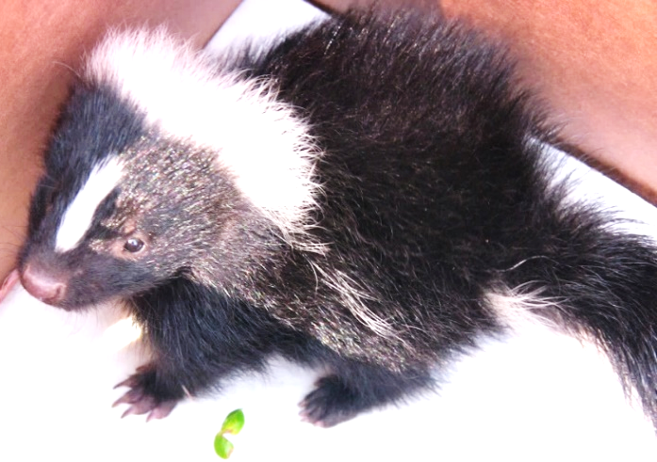
Hello Scouts,
We just wanted to touch base with you regarding your upcoming Mammal Study Merit Badge class. This badge is a two-hour class with the possibility of spending time outside on trails, depending on the weather.

Please wear long pants and shoes that can possibly get dirty. (No sandals!) If you would like, you can bring water and a snack.

Prework (Requirement 3a)
From studying and reading, write a simple life history of one non-game mammal that lives in your area. (Examples of GAME animals include deer, squirrel, bear, elk, or rabbit). In your report, please include the following:
- Tell how this mammal lived before its habitat was affected by humans
- Tell how it reproduces
- Tell what it eats
- Tell what its natural habitat is
- Describe its dependency on plants and other animals (including humans) and how they depend on it.
- Tell how it is helpful or harmful to humans
This list from the Virginia Department of Wildlife Resources may help: www.dgif.virginia.gov/wildlife/.

We will try to include building a brush shelter for mammals as part of the program. If you wish, you may choose to build a bat or squirrel box and bring it to the program. Either of those will complete the criteria for requirement 5.

We will complete the following requirements in class:
Requirement 1: Explain the meaning of “Animal, Invertebrate, Vertebrate, and Mammal.”
Requirement 2: Explain how the animal kingdom is classified, where mammals fit in this classification, and classify three mammals from phylum through species.
Requirement 4: (when possible) Take good pictures of two kinds of mammals in the wild. Record the date(s), time of day, weather conditions, approximate distance from the animal, habitat conditions and any other factors you feel may have influenced the animal’s activity and behavior.
Requirement 5: Carry out one project that will influence the numbers of one or more mammals.

If you have questions or concerns, please do not hesitate to contact us. We look forward to meeting you.

Christine Bueche-Roderick
Scout Coordinator, Merit Badge Counselor
FCPA – Sully Historic Site
3650 Historic Sully Way
Chantilly, Virginia 20151
Christine.Bueche-Roderick@Fairfaxcounty.gov
703-437-1794
Tammy Higgs
Certified interpretive Guide
Merit Badge Counselor
FCPA – Sully Historic Site
3650 Historic Sully Way
Chantilly, Virginia 20151
Tammy.Higgs@Fairfaxcounty.gov

