**ARTICLE 12**

**SIGNS**

**PART 1 12-100 GENERAL PROVISIONS**

**12-101 Purpose and Intent**

The purpose of this Article is to regulate all signs placed for viewing by the public to improve, promote and protect the public health, safety, convenience and general welfare; promote traffic safety; ensure that the First Amendment right to free speech is protected; protect property values; protect and enhance the aesthetic character of the various communities in the County; facilitate travel by identifying locations; protect against danger in travel and transportation by reducing distractions and hazards to pedestrian and automobile traffic; and, further the stated purpose and intent of this Ordinance. (12-101)

**12-102 Definitions**

For purposes of this Article, signs and their characteristics are defined as follows:

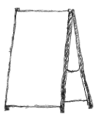A-FRAME SIGN: A temporary freestanding sign constructed to form a two-faced sign with supports that are connected at the top and separated at the base, forming an “A” shape.

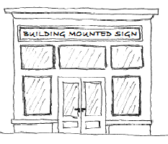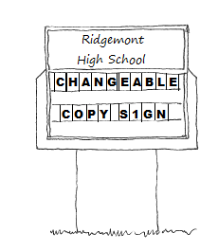BUILDING MOUNTED SIGN: Any sign attached to and supported by a building, awning, canopy, marquee or similar architectural feature, or permanently attached, etched or painted onto a window or door. For purposes of this Article, temporary window signs as defined herein are not building mounted signs. (elements of definition in Article 20)

CHANGEABLE COPY SIGN: A sign or portion thereof designed to accommodate manual changes in messages.

ELECTRONIC DISPLAY SIGN: A sign or portion thereof that contains light emitting diodes (LEDs), fiber optics, light bulbs, plasma display screens or other illumination methods, which are electronically controlled and that contain a fixed or changeable copy and/or a change to the intensity of light or colors displayed.

FLAG SIGN: Any sign made of fabric, cloth, or other pliant material that is designed to be attached to a flagpole or other structure. For purposes of this Ordinance, temporary signs are not flag signs. (elements of 12-103.2. E)

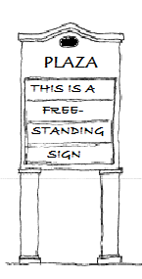FREESTANDING SIGN: Any sign other than a building mounted sign, that is permanently supported by a fence, retaining wall, entrance feature or by upright structural members or braces on or in the ground, such as a pole, pylon, or monument style structure.

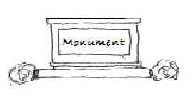MONUMENT SIGN: A freestanding sign, typically no more than 8 feet in height, that is supported primarily by an internal structural framework or that is integrated into landscaping or solid structural features other than support poles.

OFF-PREMISE SIGN: A sign that directs attention to a product, service, attraction, event, or the like that is being offered at a location that is not the premises on which the sign is located.

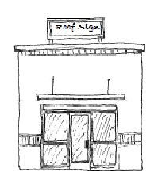RACEWAY: A structure or architectural component of a building specifically designed to support and contain a series of signs accessory to the tenants occupying space in the building. Raceways may traverse the entire length of a building and may be illuminated or constructed of materials different from that of the facade of the building.

ROOF SIGN: Any sign or portion thereof affixed to a building that extends above the lowest point of the roof level of the building, including signs painted onto a roof structure, or that is located on a chimney or other similar rooftop structure and/or mechanical appurtenance. For purposes of this Article, a roof sign does not include a sign attached to the penthouse of a building. (elements of 0f 12-203.1 and 12-207.1)

SIGN: Any writing, including letters or numerals, pictorial presentation, illustration or decoration, emblem, symbol, flag, banner or pennant or any other device, figure or similar character, to include the structure on which it is located, which is used to announce, direct attention to, identify, or otherwise make anything known, and that is visible from any street as defined in Article 20. (most of definition in Article 20)

SIGN FACE: The part of a sign which is or can be used for visual representation or communication, including any background or surrounding material, panel, trim or ornamentation, color, and illumination that differentiates the sign from the building, structure, backdrop surface, or object upon or against which the sign is placed. The term does not include any portion of the support structure for the sign if no representation or message is placed or displayed on, or designed as part of, the support structure.

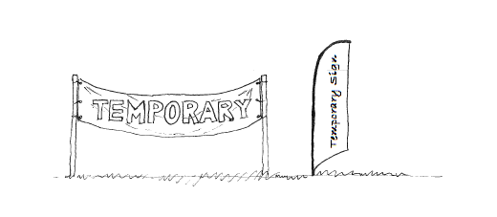TEMPORARY SIGN: A sign that is designed to be easily moved and typically is not attached permanently to a structure or the ground. Such signs include, but are not limited to, A-frame signs, banners, posters, window signs, yard signs or other moveable signs. For purposes of this Article, flag signs and vehicle signs are not temporary signs.

TENANT: An individual, entity, partnership, or corporation renting, leasing or owning non-residential space.

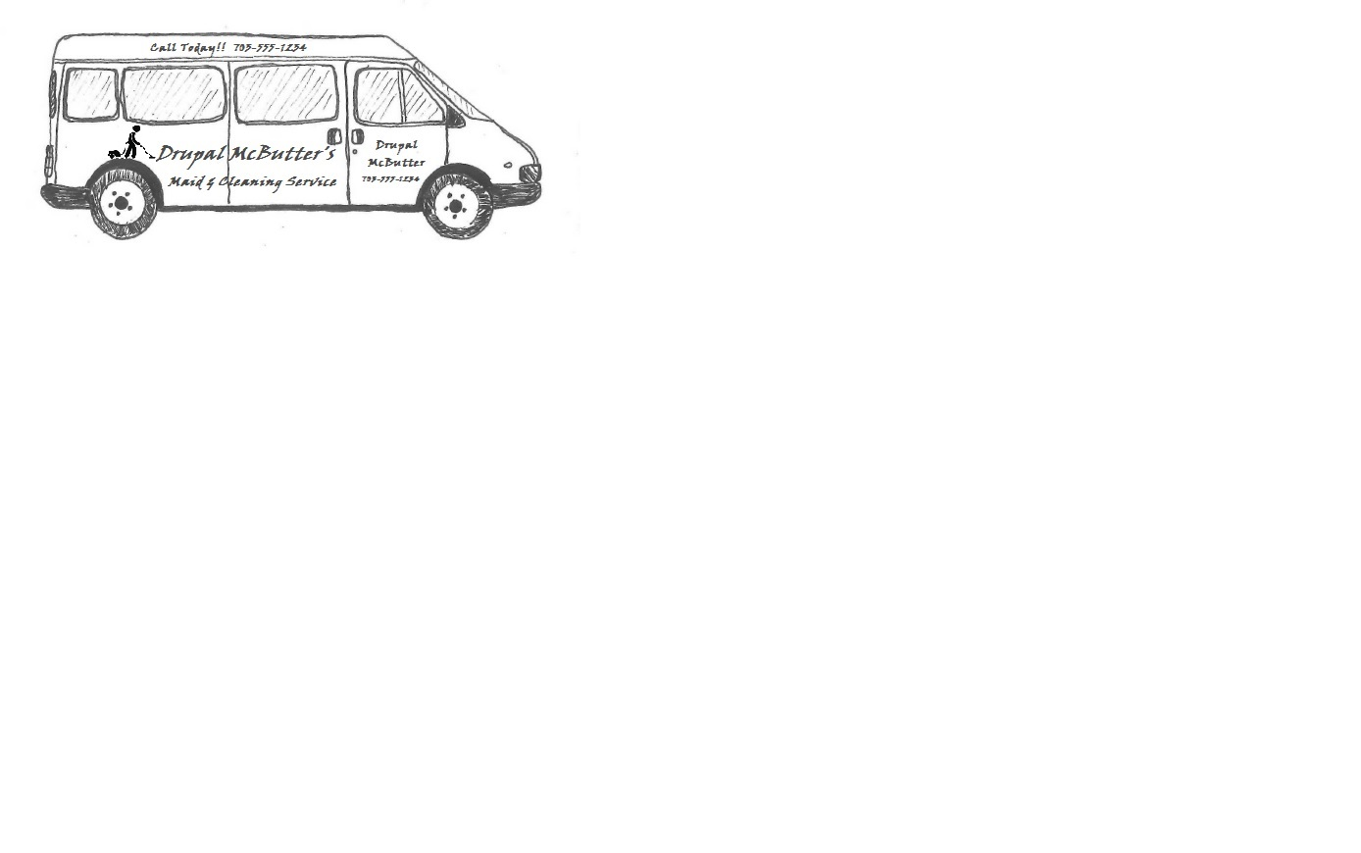VEHICLE SIGN: Any sign that is painted, mounted, adhered, magnetically attached or otherwise permanently affixed to or incorporated into a vehicle and/or trailer, except for any signs not exceeding a total of 8 square feet for the entire vehicle or trailer and bumper stickers.

WINDOW SIGN: A temporary sign that is (1) attached to the glass area of a window or placed behind the glass of a window, and (2) easily read from outdoors.

YARD SIGN: A temporary sign attached to a structure or placed upon/supported by the ground independently of any other structure but not including an A-frame sign.

**12-103 Applicability**

1. The regulations of this Article apply to all signs in Fairfax County and are in addition to any applicable provisions of Chapter 61 of the County Code (Buildings), and Title 33.2, Chapter 7, of the Virginia Code. Unless otherwise stated in this Article, however, these regulations do not apply to property owned by, or those signs required or sponsored by Fairfax County; the Commonwealth of Virginia, or any political subdivision of the Commonwealth; or, the United States. (12-103.2. B & 12-103.2.C)
2. These regulations do not regulate or restrict signs by content. However, some signs, such as off-site signs and warning signs, have a targeted function that makes their regulation impossible without referring to the function. In these limited instances, the governmental interest is compelling enough to warrant their description and regulation, and whenever a sign is described in a manner that refers to function, this Article is intended to be neutral with respect to the content of the speech appearing on it. (pt. 12-102.1)
3. All signs are deemed to be accessory uses as defined in Article 20 and must be associated with a principal use and located on the same lot as its principal use. (12-102.1)
4. Nothing in this Article excuses any person from compliance with all other applicable regulations, statutes or ordinances.
5. This Article does not apply to any sign placed in a public right-of-way and, as such, neither authorizes nor prohibits placement of any sign there.

**12-104 Administrative Provisions**

1. Except where otherwise noted in this Article, no sign may be constructed, erected, altered, refaced, relocated, or expanded without a sign permit. (Incorporates elements from 12-301.1)
2. The application for a sign permit must be filed with the Zoning Administrator on a County form, and must include all pertinent information required by the Zoning Administrator to ensure compliance with this Ordinance, and must be accompanied by the filing fee set forth in Section 18-106. (12-302)
3. All signs must comply with this Article, the structural requirements specified in the Virginia Uniform Statewide Building Code, Chapter 61 of the County Code, and, the performance standards specified in Article 14 of this Ordinance. (12-102.4, 12-107)
4. A sign permit expires if the sign is not erected and all necessary final inspection(s) are not approved within 12 months from the date of issuance. (12-303.1)
5. The following are not a sign or are actions that do not require a sign permit: (12-103.1)
6. The changing of the message on an allowed sign that is specifically designed for the use of replaceable copy, to include changeable copy signs and electronic display signs in accordance with Sections 12-203 and 12-205 below. (12-103.1. A)
7. Painting, repainting, cleaning and other routine maintenance and repair of a sign or sign structure. (elements of 12-103.1. B)
8. Flags of the United States, the Commonwealth of Virginia, Fairfax County, or other countries and states, and any flag displayed by a governmental body with a constitution. (elements of 12-103.2. E)
9. The display of address numbers as required by the County Code, and entrance numbers not exceeding a total of 2 square feet in area. When displayed on a residential building, any numbering must be mounted flush against the building. (elements of 12-103.2. F, 12-201.2, 12-202.2)
10. The following do not require a sign permit and are not counted toward maximum allowed sign area:
11. Signs not exceeding a total of 4 square feet in area warning the public against hunting, fishing, swimming, trespassing, dangerous animals, the location of utilities or other similar risks. (12-103.2.H & J)
12. Signs located on the outer surfaces of a temporary portable storage container. (12-103.2. S)
13. Vehicle signs, when the vehicle is (1) operable and (2) is parked at its associated place of business within a duly designated parking space.
14. All signs and their components must be maintained in good repair and in safe condition. (12-108)
15. The Building Official or his designated agent may require or cause the immediate removal or repair, without written notice, of any sign that he determines is unsafe or otherwise poses an immediate threat to the safety of the public. If action by the County is necessary to render a sign safe, the cost of removal or repair will be at the expense of the property owner or lessee as provided in Chapter 61 of the County Code. (12-108)
16. Except as provided in Sections 12-105 and 12-107 below, if a property becomes vacant and is unoccupied for a continuous period of 2 years, any sign on that property is deemed abandoned and must be removed. If the owner fails to remove the sign, the Zoning Administrator may give the owner 15 days written notice to remove it, after which the Zoning Administrator may initiate action to gain compliance. (12-108)

**12-105 Temporary Signs**

The following temporary signs are allowed and, unless otherwise stated, do not require a sign permit:

1. Signs posted by or under the direction of any public or court officer in the performance of official duties, or by trustees under deeds of trust, deeds of assignment or other similar instruments, if the signs are removed no later than 10 days after the last day of the period for which they are required to be displayed. (12-103.3. A)
2. Signs for real property that are displayed on a lot that is actively marketed for sale, rent or lease, as follows: (12-103.3. D)
3. A single building mounted or freestanding sign is allowed, except that 2 signs are permitted on a corner lot when each sign faces a different street frontage. Such sign(s) must be removed within 7 days of the settlement, rental or lease of the property.
4. Sign(s) located on a property developed with, or planned for development of, a single family detached or attached dwelling unit, cannot exceed 6 square feet in area and a height of 4 feet.
5. Sign(s) located on a property developed with, or planned for development of, a multiple family dwelling unit cannot exceed 12 square feet in area and a height of 8 feet.
6. Sign(s) located on a property developed with, or planned for development of, any non-residential use, or on a residential property containing a minimum of 20 acres, cannot exceed 32 square feet in area and a height of 8 feet
7. Signs during active construction of or alterations to residential, commercial, and industrial buildings are permitted, as follows: (12-103.3. F)
8. For a new residential, commercial or industrial development, one sign per lot, not to exceed 60 square feet in area and a height of 10 feet. For lots containing multiple road frontages, one additional sign per street frontage is allowed, limited to 32 square feet in area and a height of 8 feet. No sign may be located closer than 5 feet to any lot line.

All signs must be removed within 14 days following completion of construction and no sign may be displayed for more than 2 years from the date of the issuance of the first building permit for the development. If construction has not been completed within this timeframe, a sign permit is required to allow the continued display of a sign but only if there is an active building permit for the development.

1. For an individual single family dwelling unit undergoing construction, improvement or renovation, one sign, not to exceed 4 square feet in area or a height of 4 feet is allowed.

No sign can be displayed before commencement of the improvement or renovation work, and the sign must be removed within 7 days after the improvement or renovation is completed with all necessary inspections approved, or within 6 months, whichever is less.

1. Yard signs on any property cannot exceed 12 square feet in total area, with no single sign exceeding 4 square feet in area and a height of 4 feet.
2. For non-residential uses in any zoning district, temporary building mounted signs, to include signs attached to a fence, wall, existing freestanding sign or other similar accessory structures, are allowed, not to exceed 24 square feet in total area, with no single sign exceeding 12 square feet in area.
3. Window signs for any approved non-residential use are allowedif the total of all signs at a given establishment does not cover more than 30 percent of the total area of the window in which the signs are located. (12-103.3. K)
4. For uses located in a commercial or industrial district, a single A-frame sign not to exceed 6 square feet in area and a height of 3 feet, is allowed. The sign may only be displayed during business hours and must be located within 25 feet of the entrance of the building that provides access to the use and cannot impede pedestrian or vehicular traffic.

**12-106 Prohibited Signs**

In addition to signs prohibited elsewhere in the Zoning Ordinance, the following signs are prohibited in all zoning districts and areas of the County.

1. General Prohibitions:
2. Any sign not expressly permitted in this Article.
3. Any sign that violates any provision of any county, state or federal law or regulation. (12-104.2, 8 & 9)
4. Any sign that violates any provision of Chapter 61 of the County Code and the Virginia Uniform Statewide Building Code. (12-104.3)
5. Prohibitions Based on Materials or Design:
6. Any sign that does not meet the performance standards for outdoor lighting set forth in Part 9 of Article 14. (12-104.4)
7. Any sign of which all or any part is in motion by any means, including fluttering, rotating, undulating, swinging, oscillating, or any other natural or artificial means or by movement of the atmosphere, to include flag signs as defined in Sect. 12-102 above but not changeable copy and electronic display signs, the hands of a clock or a weather vane. (elements of 12-104.5)
8. Any sign displaying flashing or intermittent lights, or lights of changing degrees of intensity of color, and/or that is not in accordance with Sections 12-203 and 12-205 below. (12-104.6)
9. Prohibitions Based on Location:
10. Any off-premise sign, to include a sign located on a lot where no principal use exists, and/or any sign that projects beyond a property line, except for a sign located on a lot being offered for sale, rent or lease, or on which buildings are being constructed, as provided for in Sect. 12-105 above.
11. Roof signs, except for those signs located on a penthouse or screening wall, as provided for in Sect 12-205 below.
12. Any sign that obstructs a window, door, fire escape, stairway, ladder, opening or access intended for light, air, ingress to, or egress from, a building. (12-104.7)
13. Any sign which, due to its location, size, shape and/or color, may obstruct, impair, interfere with the view of, or be confused with, any traffic control sign, signal or device erected by a public authority or where it may interfere with, mislead or confuse traffic. These signs are subject to immediate removal and disposal by an authorized County official as a nuisance. (12-104.10)
14. Any sign located on a corner lot that is in violation of Sect. 2‑505. (12-104.11)
15. Any sign that is found to be in violation of the Virginia Uniform Statewide Building Code with respect to minimum clearance. (12-104.13)

**12-107 Nonconforming Signs (12-110, minor edits)**

1. Signs lawfully existing on the effective date of this Ordinance or prior ordinances, which do not conform to this Ordinance, and signs which are accessory to a nonconforming use, are deemed to be nonconforming signs and may remain except as qualified below. Except as provided for in a Commercial Revitalization District, such signs cannot be enlarged, extended or structurally reconstructed or modified in any manner; except a sign face may be changed if the new face is equal to or reduced in height and/or sign area from the existing sign.
2. The property owner bears the burden of establishing the nonconforming status of a sign and of the existing physical characteristics and location of a sign. Upon notice from the Zoning Administrator, a property owner must submit verification that a sign was lawfully existing at the time of erection. Failure to provide verification is cause to remove the sign or bring it into compliance with this Article.
3. Nothing in this Section prevents keeping a nonconforming sign that is in good repair; however, no nonconforming sign may be repaired, rebuilt, or restored if the Building Official has declared it unsafe, as provided for in Sect. 12-104 above unless the activity results in a sign that conforms to this Article.
4. Nonconforming signs may not be moved on the same lot, or to any other lot, unless the change in location will make the sign conform to this Article.
5. When a nonconforming sign is removed, any sign erected later must conform to this Article, except as provided for in a Commercial Revitalization District.
6. A nonconforming sign that is destroyed or damaged by any casualty not more than 50 percent of its appraised value, may be restored within 2 years after the destruction or damage, but may not be enlarged in any manner. If a sign is destroyed or damaged more than 50 percent of its appraised value, it cannot be reconstructed unless it conforms to this Article.
7. A nonconforming sign that is changed to or replaced by a conforming sign will no longer be deemed nonconforming, and any new sign must conform to this Article.
8. A nonconforming sign must be removed if the structure to which it is accessory is demolished or destroyed by more than 50 percent of its appraised value. A nonconforming sign subject to removal under this paragraph must be removed within 30days following written notice by the Zoning Administrator to the owner of the property. If the owner fails to comply with this notice the Zoning Administrator may initiate action to gain compliance with this Article.
9. If a nonconforming sign is located on property that becomes vacant and is unoccupied for a period of at least 2 years, the sign is deemed abandoned and the owner of the property must remove it. If the owner fails to do so, the Zoning Administrator may give the owner 30 days’ written notice to remove it, except as otherwise provided in Sect. 12-104 above. If the owner fails to comply with the notice, the Zoning Administrator may enter onto the property and remove the sign. Such removal may be accomplished with the assistance of any agent designated by the Zoning Administrator or hired by the County for such purpose, and, the Zoning Administrator may charge the cost of removal to the property owner. In addition, the Zoning Administrator may initiate legal action in court for an injunction or other appropriate remedy requiring the owner to remove an abandoned nonconforming sign.
10. The ownership of the sign or the property on which the sign is located does not affect the nonconforming status of the sign.

**PART 2 12-200 SIGN REGULATIONS BY USE & DISTRICT**

**12-201 Calculation of Sign Area (12-105 & 12-106, with edits)**

1. When building frontage is used to calculate allowable sign area, the following applies:
2. Building frontage is the linear width of the wall taken at a height that is not greater than 10 feet above grade. (12-106)
3. On buildings with a single tenant or with multiple tenants that access the building via a common outside entrance(s), building frontage is the face or wall that is architecturally designed as the front of the building and that contains the main public entrance, as determined by the Zoning Administrator. (12-106)
4.  On buildings with more than a single tenant where each tenant has its own outside entrance(s), building frontage for each tenant is the wall that contains that tenant's main public entrance, as determined by the Zoning Administrator. (12-106)
5. When calculating allowable building mounted sign area, the following applies:
6. 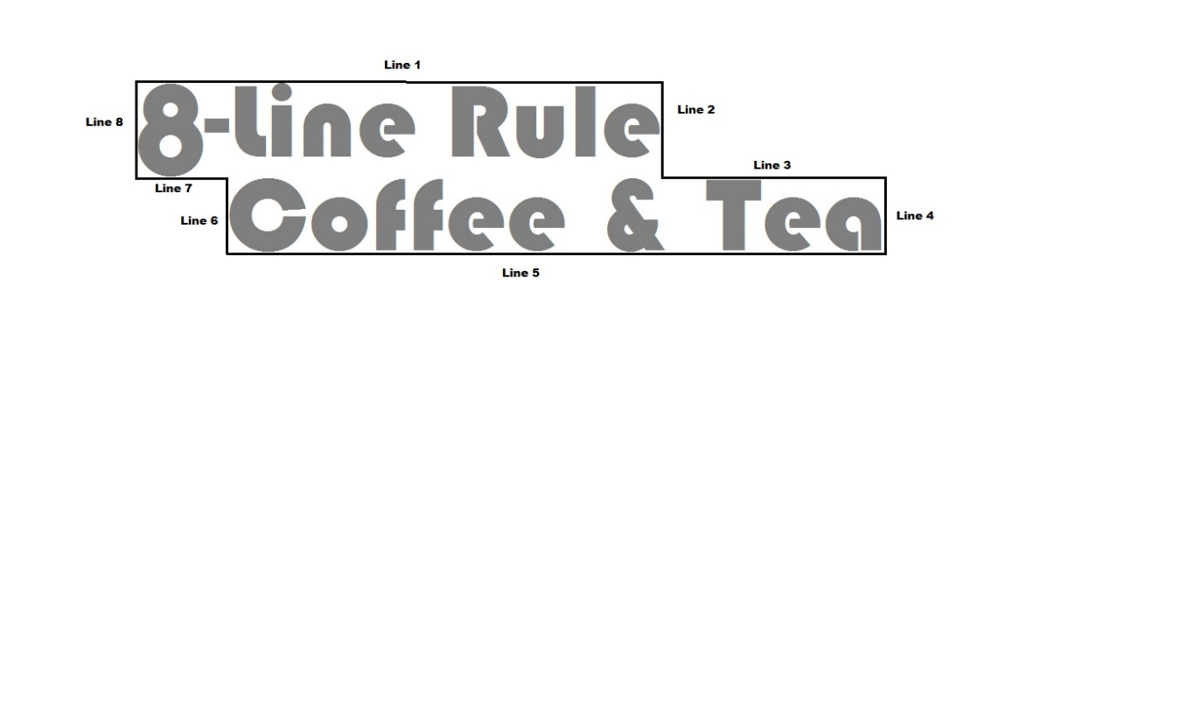Building mounted sign area is the entire area within a single continuous rectilinear perimeter of not more than 8 straight lines intersecting at right angles, which encloses the outer limits of all words, representations, symbols and/or pictorial elements, together with all material, color and/or lighting forming an integral part of the display or used to differentiate the sign from the background against which it is placed. (12-105, with minor edits)
7. The area of building mounted signs composed of individual letters and/or symbols, to include signs(s) located on a raceway, is calculated in accordance with one of the following methods: (12-105)
8. If the space between the proposed individual letters or symbols is less in dimension than the width of the largest letter or symbol, sign area is calculated in accordance with Par. 2A above.
9. If the space between the proposed individual letters and/or symbols is greater than the width of the largest letter and/or symbol, sign area is calculated as the total, combined area of rectangular enclosures surrounding each individual letter and/or symbol.

3. The following provisions apply to freestanding signs:

1. The supports, uprights or structure on which any freestanding sign is supported are not included in calculating sign area unless such supports, uprights or structure form an integral background of the display, as determined by the Zoning Administrator; however, when a sign is placed on a fence, wall, or other similar structure that is designed to serve a separate purpose other than to support the sign, the area of such structure is not included in the sign area. In such cases, the sign area is calculated in accordance with Par. 2A above. (12-105)
2. The area of a freestanding sign designed with more than one sign face is calculated in accordance the following: (12-105)
3. 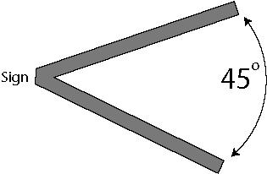If the sign faces are separated by an interior angle of 45 degrees or more, all sign faces are calculated in the sign area.
4. If the sign faces are separated by an interior angle that is less than 45 degrees, sign area is calculated based on the area of the largest single face.
5. 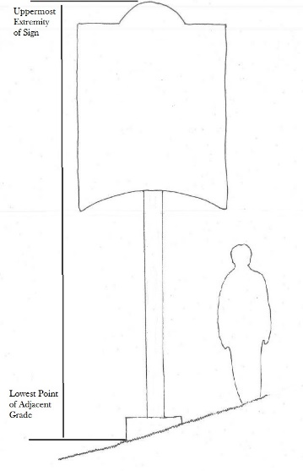If the sign faces are parallel to one another, the calculation of sign is as follows:
6. 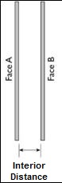The area of the largest single face is used when the interior distance between the faces is 18 inches or less.
7. The area of the largest single face and the area of the side or interval between faces is used when the interior distance between the faces is greater than 18 inches.
8. The height of a freestanding sign is calculated as the maximum vertical distance from the uppermost extremity of a sign and/or its support, to the lowest point of the adjacent grade. (12-105)

**12-202 Signs in Residential Districts (elements of 12-200, 12-201 and 12-202)**

The following signs are allowed with approval of a sign permit, as accessory to residential or non-residential land uses in a residential district, including public uses as defined in Article 20:

1. In a single family residential subdivision or a multiple family development, a freestanding is allowed at each major entrance, not to exceed 30 square feet in area and 8 feet in height. More than one sign may be placed at each major entrance but the total of all signs at a single entrance cannot exceed 30 square feet in area. (12-201.4 and 12-202.4)
2. A rental office for a multiple family development is allowed one building mounted or freestanding sign not to exceed 4 square feet in area and a height of 4 feet. (12-202.5)
3. Agricultural uses on a lot at least 20 acres in size are allowed a total of 60 square feet of sign area. No single sign can exceed 30 square feet in area and a height of 8 feet. (12-103.2. K)
4. Hospitals, as follows:
5. A single building-mounted sign for each building entrance, not to exceed 50 square feet in area.
6. A single freestanding sign at each entrance, not to exceed 80 square feet in area and 12 feet in height. (12-208.2.G)
7. All other non-residential uses, including public uses as defined in Article 20, are allowed building mounted and freestanding signs in accordance with the following, although the BZA, in approving a special permit, or the Board, in approving a rezoning or special exception, may further limit any sign for any land use in furtherance of those provisions set forth in Sections 8-007 and 9-007 of the Ordinance:
8. Building mounted signs cannot exceed 50 square feet in total area, with no single sign exceeding 32 square feet in area.
9. A single freestanding sign not to exceed 40 square feet in area in area and 8 feet in height.

***Alternative option for freestanding signs:***

1. *Freestanding signs as follows:*
2. *For properties containing less than 5 acres, a single freestanding sign, not to exceed 16 square feet in area and 4 feet in height.*
3. *For properties containing a minimum of 5 acres but less than 20 acres, a single freestanding sign, not to exceed 32 square feet in area and 6 feet in height.*
4. *For properties containing more than 20 acres, a single freestanding sign, not to exceed 40 square feet in area and 8 feet in height.*

**12-203 Performance Standards for Signs in Residential Districts**

1. Building mounted signs must be installed flush against the wall and cannot extend above or beyond the perimeter of the wall or roof of the building to which they are attached. (12-208.2)
2. *Freestanding signs cannot be located closer than 5 feet to any property line.*
3. Changeable copy and electronic display signs are allowed as part of any freestanding sign, in accordance with the following:
4. Only one changeable copy or electronic display sign is allowed per lot. The area of the changeable copy or electronic display cannot exceed more than 50 percent of the maximum allowable area of that freestanding sign.
5. The message or copy of an electronic display sign cannot move and/or change more frequently than once every 8 seconds. The change of message or copy must be instantaneous without rolling, fading, or otherwise giving the illusion of movement, nor flash or vary in brightness.

***Alternative option, in conjunction with Par. 2 above:***

1. *Changeable copy and electronic display signs are allowed in accordance with the following:*
2. *As part of a monument sign, with a maximum height of 6 feet.*
3. *The message or copy of an electronic display sign cannot move and/or change more frequently than once every 8 seconds. The change of message or copy must be instantaneous without rolling, fading, or otherwise giving the illusion of movement, nor flash or vary in brightness.*
4. *Electronic display signs must include a photo cell to control brightness and automatically dim at sunset to a nighttime level of 40-100 nits.*
5. Illumination of signs must conform to the performance standards for outdoor lighting as set forth in Part 9 of Article 14. (12-201.3, 12-202.3, and 12-208.2)

**12-204 Signs in Commercial and Industrial Districts**

The following signs are allowed with approval of a sign permit, as accessory to land uses located in a commercial district, including the commercial area of a P district and/or commercial uses located in a mixed-use building or development; or in an industrial district, including public uses as defined in Article 20:

1. Building mounted signs are allowed as follows:
2. For buildings with a single tenant or with multiple tenants that access the building by one or more common outside entrances, signs are limited to 1½ square feet of sign area for the first 100 linear feet of building frontage, plus one square foot of sign area for each additional linear foot of building frontage. However, no single sign may exceed 200 square feet in area. (12-203.8 and modified 12-207.3)
3. For buildings with more than a single tenant where each tenant has its own outside entrance(s), signs cannot exceed 1½ square feet of sign area for each linear foot of building frontage occupied by each tenant, except as provided for in Sect. 12-301 below. The maximum sign area for any single tenant cannot exceed 200 square feet.

However, a single tenant, (1) having building frontage that results in an allowable sign area greater than 200 square feet and (2) occupying an area with more than one perimeter wall containing a main public entrance, may place up to a maximum of 200 square feet of total sign area on each such perimeter wall, although the combined sign area on any such wall cannot exceed 1 ½ times the length of the wall. (12-203.9 and modified 12-207.4)

1. In addition to sign area allowed in accordance with Par. A or B above, hospitals are allowed a single building mounted sign for each building entrance. No such sign can exceed 50 square feet in area. (12-203.14 & 12-207.13)
2. Freestanding signs are allowed as follows, unless further limited by Par. 3 below:
3. In a commercial zoning district,a single tenant may have one freestanding sign up to 80 square feet in area and 20 feet in height, if the tenant is not located within or on the same lot as a shopping center (12-205.2), but on a lot that has frontage on a primary highway or on a major thoroughfare. (12-203.4)
4. In an industrial zoning district, a single freestanding sign not to exceed 80 square feet in area and 20 feet in height may be erected for each building that has frontage on a major thoroughfare. However, if one tenant occupies a group of separate buildings with frontage on a major thoroughfare, that tenant is allowed only one freestanding sign. (12-207.5 and 12-207.7)
5. A hospital is allowed a one freestanding sign at each entrance, and no such sign may exceed 80 square feet in area and 12 feet in height. (12-203.14 & 12-207.13)
6. Shopping centers are allowed one freestanding sign, not to exceed 80 square feet in area and 20 feet in height. If a shopping center has frontage on 2 or more major thoroughfares, however, it may have a second freestanding sign (for a total of 2 freestanding signs). (12-203.10, 12-205.3 & 12-12-206.3)
7. For office and industrialparks:
8. One freestanding sign is allowed at each major entrance to the office or industrial park, not to exceed 40 square feet in area and a height of 20 feet. (12-203.13.A and 12-207.12.A)
9. One freestanding sign is allowed for each detached building that houses a principal use within an office or industrial park, not to exceed 20 square feet in area for an office park, 30 square feet in area for an industrial park, and 8 feet in height. (12-203.13. B and 12-207.12. B)
10. The following regulations apply only to uses located on commercially and industrially zoned land located within a Sign Control Overlay District; where applicable, they are in addition to and supersede, Par. 2 above: (12-204)
11. A single tenant or building on a lot may have one freestanding sign if, (1) the lot has frontage on a primary highway or major thoroughfare and, (2) the single tenant or building is not located within or on the same lot as a shopping center. The sign cannot exceed 40 square feet in area and 20 feet in height.
12. A shopping center is allowed is allowed one freestanding sign not to exceed 40 square feet in area and 20 feet in height.

**12-205 Performance Standards Required for All Signs in Commercial and Industrial Districts**

1. Building mounted signs may be located anywhere on the surface of a wall but no part of the sign may extend above or beyond the perimeter of a wall, except when the sign is erected at a right angle to the wall, does not extend into the minimum required yard, and is not located closer than 2 feet to any street line. (pt. 12-203.1 and 12.207.1, and 12-203.2 and 12.207.2)
2. A building mounted sign may be located on the wall of a penthouse or rooftop screening wall, as follows: (pt. 12-203.1 and 12.207.1)
3. The sign must be mounted flat against the wall, and no part of the sign can extend above or beyond the perimeter of the wall.
4. The sign cannot be located more than 12 feet above the building roof supporting the penthouse or screening wall.

1. Freestanding signs may not project beyond any property line or be located within 5 feet of the curb of a service drive, travel lane or adjoining street. When located on a corner lot, a freestanding sign is subject to Sect. 2‑505 of this Ordinance. (12-203.5 & 12-207.6)
2. Changeable copy and electronic display signs are only allowed as part of any freestanding sign, in accordance with the following:
3. Only one changeable copy or electronic display sign is permitted per lot. The area of the changeable copy or electronic display cannot exceed more than 50 percent of the maximum allowable area of that freestanding sign.
4. The message or copy of an electronic display sign cannot move and/or change more frequently than once every 8 seconds. The change of message or copy must be instantaneous, without rolling, fading, or otherwise giving the illusion of movement, nor flash or vary in brightness.

***Alternative option based on Board input, to include Par. 2 above, the minimum required setback:***

1. *Changeable copy and electronic display signs are allowed as part of any freestanding sign, in accordance with the following:*
2. *The message or copy of an electronic display sign cannot move and/or change more frequently than once every 8 seconds. The change of message or copy must be instantaneous, without rolling, fading, or otherwise giving the illusion of movement, nor flash or vary in brightness.*
3. *Electronic display signs must include a photo cell to control brightness and automatically dim at sunset to a nighttime level of 40-100 nits.*
4. Illumination of signs must conform to the performance standards for outdoor lighting as set forth in Part 9 of Article 14. (12-203.6 & 12-207.8)

**12-206 Other Permitted Signs**

1. The following signs are only allowed in a commercial or industrial district, or the commercial area of a P district, in addition to those sign types and amounts allowed in Sect. 12-204above:
2. Service stations or service station/mini-marts are permitted one additional square foot of sign area for each gasoline pump. (12.203.11 & 12-207.10)
3. Motor vehicle fuel price signs required by Article 4 of Chapter 10 of The Code. (12-203.12 & 12-207.11).
4. Accessoryservice uses allowed pursuant to Sect. 10-200 are allowed a single building mounted sign not to exceed 15 square feet in area. These signs will be calculated as part of the total allowable building mounted sign area for the building. (12-209, modified)

**Part 3 12-300 SPECIAL APPROVALS**

**12-301 Administrative Comprehensive Sign Plan (12-106.3)**

As an alternative to calculating building frontage in accordance with Par. 1B of Sect. 12-201 above, the Zoning Administrator may authorize a different allotment of sign area to the various tenants of a building or buildings by approval of an administrative comprehensive sign plan, as follows:

1. A request for an administrative comprehensive plan must include written authorization from the owner of the building(s), or an authorized agent, accompanying graphics showing the proposed size, height and location of all signs, and the required filing fee as set forth in Section 18-106.
2. The total area for all signs may not exceed the maximum allowable sign area for the building as determined in accordance with Par. 1.B. of Sect. 12-201 above. The maximum sign area for any single tenant cannot exceed 200 square feet.

However, a single tenant, (1) having building frontage that results in an allowable sign area greater than 200 square feet and (2) the tenant occupies an area with more than one perimeter wall containing a main public entrance, may place up to a maximum of 200 square feet of total sign area on each such perimeter wall, although the combined sign area on any such wall cannot exceed 1 ½ times the length of the wall.

**12-302 Special Permits (12-304, minor edits)**

1. The BZA may grant a special permit to increase the height of a freestanding sign in a neighborhood or community shopping center where, in its opinion, this Article would cause a hardship due to issues of topography. However, such freestanding sign cannot extend to a height greater than 26 feet above the elevation of the center line of the nearest street. (12-304)

1. The BZA may grant a special permit to allow additional sign area and/or height, or a different arrangement of sign area distribution for a regional shopping center where, in its opinion, this Article would cause a hardship due to issues of topography or location of the regional shopping center. However, the total combined sign area for the regional shopping center cannot exceed 125 percent of the sign area otherwise allowed by the provisions of this Article. (12-304)
2. In cases where an individual or grouping of enterprises within a shopping center are located so that the building frontage is not visible from a street, the BZA may grant a special permit to allow building mounted sign(s) for such enterprises to be erected at the entrances, arcades or interior malls. However, the total combined sign area for the shopping center cannot exceed 125 percent of the sign area otherwise permitted by this Article. (12-304)

**12-303 Special Exceptions (12-305)**

1. In conjunction with the approval of a special exception for a hospital, the Board may approve additional signs for the use in accordance with Sect. 9‑308. (12-208.2G)
2. In commercial and industrial districts, the Board may approve, either in conjunction with the approval of a rezoning or as a Category 6 special exception, a modification or waiver of the sign regulations in accordance with Sect. 9‑620. (12-305)

**12-304 Uses in P Districts (elements of 12-210)**

The provisions set forth in the preceding Sections apply to signs accessory to uses in P districts. However, in keeping with the intent to allow flexibility in the design of planned developments, the following is applicable to signs in P districts:

1. Signs may be permitted in a P district in accordance with a comprehensive sign plan subject to approval by the Planning Commission following a public hearing conducted in accordance with Sect. 18‑109. The comprehensive sign plan will show the location, size, height and extent of all proposed signs within the specified area of the P district.

1. An application for a comprehensive sign plan may be submitted by any property owner, owner of an easement, lessee, contract purchaser or their agent. The application must be accompanied by a statement setting forth the names of the record owners of the properties upon which such signs are proposed to be located, and a fee as set forth in Sect. 18‑106.
2. Any comprehensive sign plan must be in accordance with the standards for all planned developments as set forth in Part 1 of Article 16. All proposed signs must be in scale and harmonious with the development and so located and sized as to ensure convenience to the visitor, user or occupant of the development, while not adding to street clutter or otherwise detracting from the planned unit nature of the development and the purposes of architectural and urban design elements.