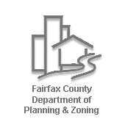
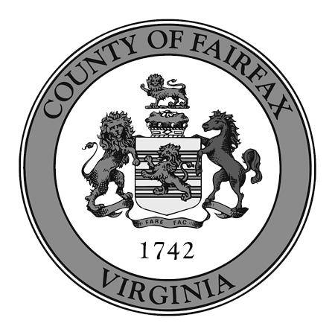
FAIRFAX COUNTY LAND USE
OUTREACH & COMMUNICATIONS TOOLS

The Department of Planning and Zoning, with the support of Office of Public Affairs, uses the following tools for providing information related to the various land use projects, amendments and applications that are reviewed and processed by the department. The specific tools and techniques are used as appropriate based on the specific circumstances and scope for the specific project, amendment or application being considered.
Public outreach on land use applications and public facility (2232) applications going through the review process is the responsibility of the applicant and informed by the District Supervisor; information at the end of this document addresses common methods of outreach for these cases.
- Community meetings: These meetings range from informational to more directed discussions to charrettes to help in decision making. Public task forces are often established for Comprehensive Plan studies, and these meetings are facilitated to provide specific recommendations. In other instances, particularly for zoning ordinance amendments, community wide meetings are held to provide information about proposed amendments, as well as gather input. Charrettes also have been used to gather public input or help reach decisions, and recent examples include the planning efforts for Seven Corners, Lincolnia and Embark Richmond Highway.
- Open houses: These less-formal meetings provide an opportunity for the public to learn about a specific project(s) while interacting one-on-one with county staff. As an example, multiple open houses were held during the Embark Richmond Highway planning process, and a well-attended Zoning Open House was held last summer to allow the public to learn about multiple amendment at once.
- Stakeholder consultations: Staff will consult directly with specific stakeholder groups, such as civic or homeowners associations and industry representatives, to gather feedback. For example, these consultation occurred with reviews of new Comprehensive Plan policy that allows for repurposing of office structures for other uses and for the craft beverage zoning ordinance amendment and the ongoing short term lodging zoning amendment.
- County website: Specific webpages are created for every plan and most zoning amendments, and these pages offer comprehensive information, including presentations made to the public, frequently asked questions, videos, draft plan or zoning text, public feedback gathered and staff reports. (The status of pending land use cases, as well as published staff reports and proffer statements, are available on the county’s website.)
- Listservs: For many projects, the county establishes email listservs so that interested members of the public subscribe to can stay informed about specific projects. These project-specific listservs are in addition to the standing listservs for the Planning Commission, Comprehensive Plan Amendments, Proposed Zoning Ordinance Amendments and Adopted Zoning Ordinance Amendments.

- Media Relations: The county conducts outreach to the local media to inform them about proposed studies and amendments. This includes notices about upcoming meetings, key decision or actions, and final adoption of plan and zoning changes.
- Social Media: Twitter and Facebook are used to announce meetings for studies or amendments, seek public feedback, and final adoption of key studies and amendments. This includes the use of individual Facebook pages for land use studies and zoning related issues, as well as the county’s main Facebook page. Facebook has also been used to livestream community meetings, such as the recent Office Repurposing amendment.
- Nextdoor: This relatively new social, platform allows the county to communicate with neighborhoods in a specific geographic area. The county government has an overall account, and each Board of Supervisors office have access to their own individual government accounts. To date, the main county account has been used to announce community or task force meetings for plan or zoning projects. For example, Nextdoor has been used to announce meetings for the Dulles Suburban Study and the Zoning Ordinance Modernization Project, known as zMOD. While Nextdoor can be a powerful tool, residents do not opt-in—or subscribe—to messages from the county. Some do not appreciate the unsolicited information, leading them to block future messages from the county.
- Surveys: When appropriate, online surveys are conduct to solicit public feedback. As an example, this was done for recently for the Short-Term Lodging Zoning Amendment and Zoning Ordinance Modernization project.
- Online Chats: Online chats have been conducted for specific projects such as Embark Richmond Highway. These chats allow the public to submit questions in advance of scheduled chat time, as well as in real time.
- Videos: Videos are used to provide information about specific plan or zoning amendments. As an example, there was a four-part series created for the Site Specific Plan Amendment Process.
- Fact sheets, fliers: Collateral materials are created for projects as appropriate, such as fact sheets that distributed in person and online. Fliers are also used to announce meetings like fliers posted at community centers and on Connector buses for Embark Richmond Highway.
- Mailings: Mailings are sent to specific geographic areas or neighborhoods as appropriate, and letters are also sent to civic or homeowners associations.
Legal Notification and Public Outreach on Land Use Applications
Land use applications include cases heard by the Planning Commission (including 2232s), the PC and the Board of Supervisors, or the Board of Zoning Appeals. Public Outreach on these cases is the responsibility of the applicant and is informed by the District Supervisor. Legal Notification (which also serves an outreach function) is set by the State Code and the Zoning Ordinance and is the responsibility of both County Staff and the applicant.
- Community meetings: Depending on the application and the Supervisory District, these meetings take different forms, but the basic goal is to inform the surrounding community and elicit comments, issues and questions. Some meetings may include formal votes of support/no support. Planning and Zoning Staff are not staff support for these meetings, however upon request may attend to discuss process and/or a particular application, when appropriate. Community meetings may include:

  - Formal Land Use Committees that meet on a regularly scheduled basis (usually monthly) to review and discuss land use cases and issues. These committees usually also review County-driven projects such as Zoning Ordinance Amendments and Plan Amendments.
  - Formal Land Use Committees that meet on an as-needed basis (ie., when a case is filed) to review and discuss land use cases and issues. These committees may also review County-driven projects such as Zoning Ordinance Amendments and Plan Amendments.
  - Project-specific meetings that are organized by either the applicant or the District Supervisor’s office. These may be broad (for an entire community), or may be targeted at a particular neighborhood or homeowners’ association.
- County website:
  - The Land Development System provides the status of pending land use cases, as well as published staff reports and related information. Search functions include by or around an address, tax map, case number, or even name of participant.
http://ldsnet.fairfaxcounty.gov/ldsnet/
  - The Planning and Zoning Viewer is an interactive map with information about current zoning applications and zoning layers for areas with in Fairfax County. The map can be customized and printed. The Viewer is accessed through the DPZ mapping page.
https://www.fairfaxcounty.gov/planning-zoning/maps-and-geographic-applications
  - My Neighborhood is an interactive mapping application that allows users to find information related to addresses in Fairfax County. It includes links to other public web applications with information about real estate tax assessments, land development, and crime.
http://www.fairfaxcounty.gov/myneighborhood/
- Legal Notifications: The information included in the notice (the same text is used for all three types) is proscribed by the Zoning Ordinance (Sect. 18-110) and state law (Sect. 15.2-2285 of the Code of Virginia). Applicants may not include their own information in the mailing.
  - Post physical signs on property (posted by County, not required by State Law)
  - Mail notices to adjacent property owners (notices provided by County, usually mailed by applicant with return receipt to County)
  - Run ad in newspaper (run by County)
- Open Houses: These less-formal meetings provide an opportunity for the public to learn about a series of project(s) while interacting one-on-one with county staff and/or the applicant. Usually organized when a large number of land use cases have been filed in a particular geographic area, such as the annual Tysons Open House held with the Tysons Partnership in the years immediately following adoption of the new Comprehensive Plan in 2010. Land use cases are usually only one of the areas of focus of an open house.

# # #

